**Open Source Graphics & Animation Tools**

**MID-SEM EVALUATION**

**MARCH 2020**

**Submitted to**

**Dr. Durgansh Sharma**

**Professor, Cybernetics SCS, UPES**

**Submitted By**

Name: Varun Tandon

Roll No: 65

SAP ID: 500068131

B. Tech CSE (OSSOS) Department of Cybernetics

COMPUTER SCIENCE & ENGINEERING



**School of Computer Science**

**University of Petroleum and Energy Studies,**

**Dehradun – 248007: Uttarakhand**

Table of Contents

Phase- 2: 3

Project on Blender 3

Topic: CARTOON CHARACTER CLIFF JUMPING ANIMATION(2D) 3

Procedure: 3

# Phase- 2:

# Project on Blender

# Topic: CARTOON CHARACTER CLIFF JUMPING ANIMATION(2D)

## Procedure:

Step1: First open new project in 2d animation. And open the scene image file feom import.

Step2: Add the materials accordingly by choosing the base color repectively for every character and obects used.

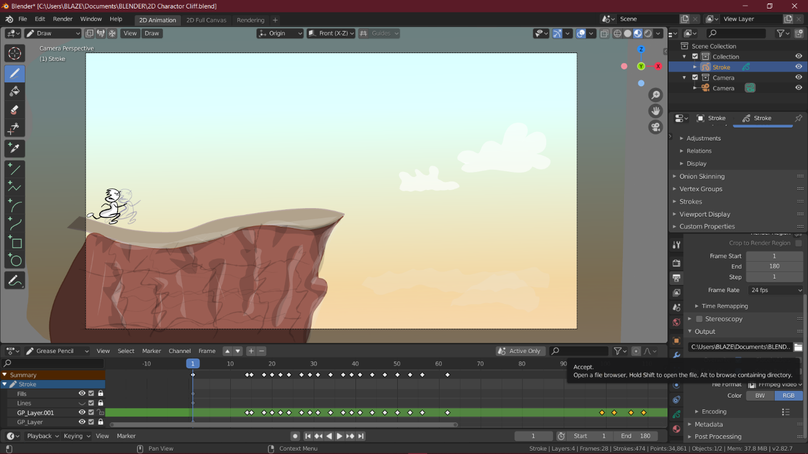

Step3: The add colors to each frame with respective material selecting from the material properties situated at the right pane.

Step4: Then going to the draw mode from leftop corner draw using pencil and proper materials to draw cliff and its background and finally the cartoon character

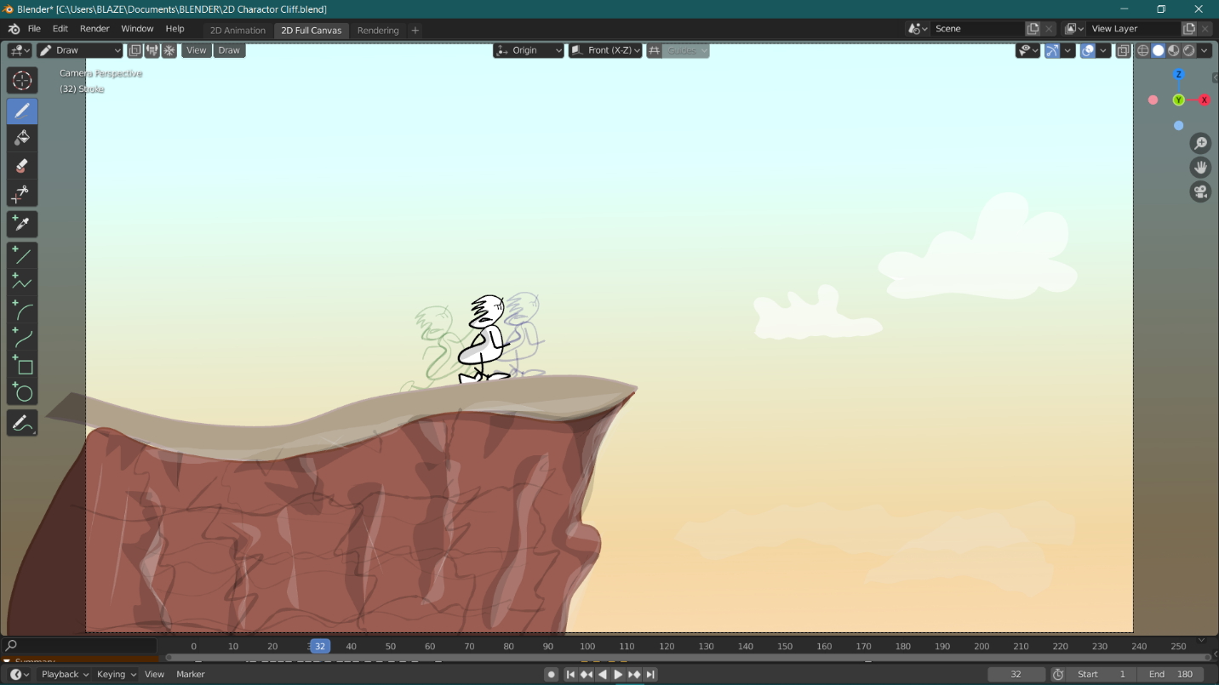

Step6: Now in the edit mode select whole cartoon character and edit it in each frame which makes it feels like it is running to every frames using appropriate diff in the key frame

Step7: also using rote and scaling to make it more real.

Step8: Now copy the running frame and place it after the current fram and idit it through the roof of the mountain

Step9: Now in draw mode make the last falling effects and emotion changing with pencil and scaleing the effect acordingly

Step8: Now set the render output properties as

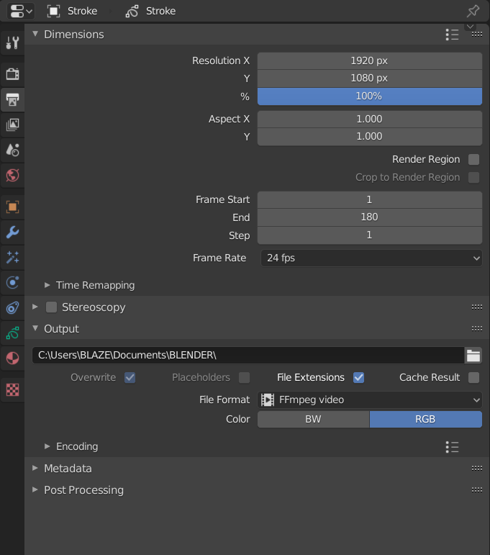

Step18: Now render this animation and save the output.

**Final View:**

[**https://photos.app.goo.gl/M7c2cznufX2vdZdJA**](https://photos.app.goo.gl/M7c2cznufX2vdZdJA)

**Output:**

Output video in zip file.